Waterway Recovery Group
in conjunction with
[Site Host]

SITE SPECIFIC PROJECT PLAN
[Site]

Version 1

[Date]

Name:
Position:

Site |  |  |  | PP Title | e.g. Concrete Channel Construction |  |  | Ref
Work Area
Assessor |  |  |  |  |  |  | Date Assessed
Review |  |  |  |  |  | Forecast Retirement Date
SITE DESCRIPTION
Site Location:
[Postal Address]
What3words:

[Insert Map]
[Route to Location].
Site Details: [summary of the site situation]

Site Setup: e.g. A compound area will be established by the site hosts to the west of the bridge in an area that was previously used. Parking, welfare and materials storage will be set up in this area. The compound is next to the access road and readily available for deliveries.

[Details of site plans and drawings provided by host restoration group]

e.g. The following sketch indicates the approximate extent of the work compound (C) and site (S). The road/bridleway/track with public access is hatched.

[insert sketch]

What are the jobs that need to be done during the Camp(s)
e.g. The stream has been now diverted through the two culvert pipes and under the concrete channel constructed during 2024. Two WRG camps shall install the two approach wing walls to this concrete channel, commence the blockwork wall for the towpath and reinstatement of earthworks outside of the concrete walls.
- Work Task 1: Construction of reinforced concrete base slab.
(including blinding, reinforcement, base formwork, kicker construction).
- Work Task 2: Construction of reinforced concrete walls.
(including preparation of kicker, water bar, reinforcement, formwork).
- Work Task 3: Construction of concrete blockwork wall and other site activities. (includes repairs to existing brickwork walls, laying of coping stones)
- Work Task 4: Backfill to concrete walls including towpath construction.
Subsequent tasks will be completed by a WRG Regional Group weekend visit to complete Work Tasks 3 and 4.

KEY SITE WIDE HAZARDS

Example details:

Although the actual construction site is not accessible to the public, vehicle/plant access to both sides of the work site is by public road and the access into the north side compound is off a public track. Therefore, awareness and caution are necessary when operating in these areas. Leaving the north side, gated access is on a steep gradient, and the west side (right-hand drivers’ side) is obscured by an embankment, so caution is needed when departing left over the bridge.

Temporary access will be made under the bridge on the canal bed. There will be access from the southern field side. The field is used for grazing several horses. The field gate must be shut when not in use or policed when being used. Access to towpath under the bridge is prohibited due to the risk of falling from height and will be barriered off.

Plant will be operating on the site. Volunteers will be instructed how to move around plant. Plant will only be operated by volunteers who hold a current Driver Authorisation for the item of plant or are being given instruction and supervised by an authorized instructor. Plant movements will be assisted by a banksman.
Plant will be stopped and isolated when pedestrians are passing.

Working near water, although the stream is not deep or normally fast flowing there is a risk of flooding of the culvert site following heavy rain. The weather forecast for the day will be reviewed to be aware of any weather that may result in a flash storm and resulting stormwater flooding.

There is a risk of leptospirosis from infected rats’ urine in the water. Hand washing before food and drink consumption is necessary. Hand protection and the treatment of any cuts is required. A leptospirosis information card is available. Stagnant water may also attract biting/stinging insects so insect repellent and bite treatment will be provided.

The nature of the approach wing walls means that there are excavations required into which the walls will be built. The sides of the excavations are battered or benched to prevent collapse and foot access into the excavations will be via a shallow gradient ramp located at the bridge end of each excavation.

Unprotected height risks in addition to the towpath exist on the bridge embankments and access is prohibited. Materials such as formwork and reinforcement bars will need to be moved around the site. Where possible mechanical lifting equipment will be used. Volunteers will need to be instructed in correct manual handling techniques and will be supervised during lifting operations.

Concrete and fuel are hazardous substances. Volunteers will be given instruction in their use and will follow guidance in the COSHH assessments.

Concrete pump hose use has an inherent risk of whiplash under certain circumstances, i.e. a concrete plug in the pipe builds up excessive pressure on its release causing the pipe end to react as the concrete is expelled. Pumping will be intensively monitored and supervised to identify risk events and instruct accordingly how the blockage will be safely cleared.

Vibration from concrete poker vibrator may require rotation of personnel to prevent risk of vibration injury.
Reinforcement bars when installed provide an impact hazard and require protective caps both on vertical and horizontal ends where site personnel may encounter bar ends. Reinforcement tying wire may produce sharp ends, even where care has been taken to make safe, gloves and long sleeves may reduce skin penetrations.

Volunteers should be aware of protruding and upstanding bars particularly when working on or around the base cages. Awareness and consideration of working position with respect to other volunteers should be maintained when tying reinforcement bars to avoid injury in the event of tie failure.

Working platforms for concreting channel walls fall under Working at Height rules and will be provided with appropriate handrail systems.
The concrete invert to the channel and below the bridge will be used to undertake a significant number of activities and store a large amount of the materials being used within the works. This is a constrained area and will require continual supervision to ensure that all activities are undertaken safely with consideration and integration for one another. The volunteer induction will specifically draw attention to this, and specific material storage areas will be identified through signage.
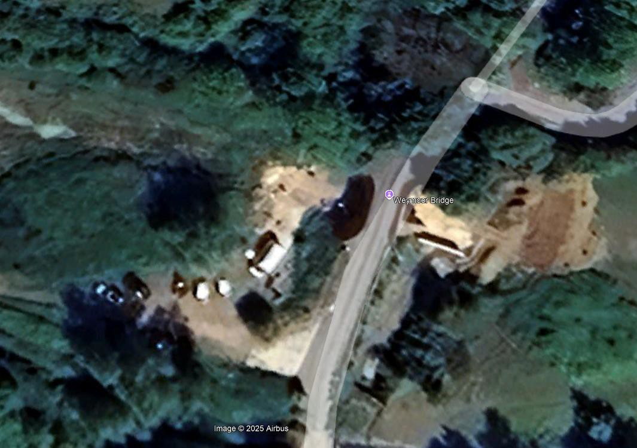
The approximate compound area layout is shown below. Given the requirement for access by large vehicles such as the concrete pump and concrete delivery lorries, care should be given to keep key areas clear of materials.

Trailer

Toilet

Welfare

Concrete Pump & Delivery Lorry
Parking Location
WRG LOGISTICS
Site Leader Team | WRG Canal Camp Leader:  WRG Assistant Leader:  Duty Director:
Host Group Contact(s)
Landowner Contact
Site First Aiders
Number of Volunteers on site | [Details]  All visitors must check in with the Canal Camp Leader to ensure they are given a basic site induction before going on site.

HEALTH AND SAFETY
WRG is part of The Inland Waterways Association, a registered charity.
- IWA provides the Health & Safety policy
- WRG implements the Health &Safety Policy through the WRG Board
All WRG tasks undertaken on the Canal Camp will be subject to CDM 2015, and as such, all activities on site will be planned to identify hazards and minimise or where possible eliminate them during the design on activity planning stage. All activities will be subject to a safe system of work / method statement / job description, with supporting risk assessments.
Canal Camp leaders will implement the requirements and measures stated in the method statement with supporting risk assessments. The Canal Camp leader will also be responsible for ensuring that volunteers work safely and in accordance with WRG policy and implement the following:
- When a volunteer arrives at the camp, they will be given a health and safety induction or talk before being allowed to work on the site. The talk will reinforce general site procedures and provide specific details for the site and project they will be working on.
- The talk will introduce the documentation for the site and the projects being undertaken. Such documentation will include the method statement and accompanying risk assessment. Other documents such as IWA’s Incident Report Form will also be introduced during this brief.
- It is made clear to volunteers that as part of the Health and Safety at Work etc Act 1974 that they have a legal responsibility in the health and safety operations of the project.
- All volunteers will be required to sign a register stating that they have received the site induction talk, and that they are willing to always follow the camp leaders’ directions. The signed register will form part of the documentation pack to be taken onto the work site, and the signed register will be returned to IWA Head Office on completion of the project and will be kept on record.
- All relevant documentation (including a copy of the Practical Restoration Handbook) will be taken on site every day.
- At all times during Canal Camps the camp leader will ensure that volunteers are given sufficient instruction and supervision to enable them to undertake any tasks requested of them in a safe manner. This will include frequent informal communication and utilisation of the method statement as a toolbox talk style briefing. Through regular communication, the Camp leaders will check that volunteers understand the task in hand and help to ensure that health and safety is at the forefront of everyone's mind.
In the event of an incident or near miss on site, camp leaders will complete the IWA Incident Report Form to inform IWA Head Office and the WRG Board. The WRG Board will seek to learn any lessons that result from the incident or near miss and where necessary, mandate changes to the operating procedures.
CDM CONSIDERATIONS
CDM 2015 is the main set of regulations for managing health, safety and welfare on all small or large construction projects and applies to all construction work as well as maintenance. CDM regulations will apply to most, if not all Canal Camps.
Client: [usually the host restoration group]
Designer: [name]
Contractor: Waterway Recovery Group
Are there any other contractors (or volunteer groups) on site? Yes/No (delete as appropriate)
Is your project ‘Notifiable’? Please answer yes or no to the following question: Is your project expected to last MORE than 30 working days and have MORE than 20 workers working on site at any one time, OR involve MORE than 500 person days? Yes/No (delete as appropriate)
- If you answered NO your project is not notifiable.
- If you answered YES, your project is notifiable and will require the submission of a F10 and further role appointments.

ACCESS ARRANGEMENTS
[How to get to the site, including details of any locked gates, etc.]

Working hours are generally 09.00 to 17.00.
WELFARE ARRANGEMENTS
Welfare will be established in the compound area. There is space for parking and setting up the WRG gazebo and Burco. [Details of hired in portable toilet or other arrangements].
EMERGENCY INFORMATION
Nearest Hospitals to site and accommodation:

The directions to each will be held in the vans, the flight case and in the accommodation. Mobile phone signal at site:
ACCIDENTS AND INCIDENT REPORTING
All accidents, incidents or near misses should be reported via the accident book or on a near-miss postcard located in the first aid box. These should be sent to Head Office at the end of the Camp.
Serious accidents/incidents or any damage to WRG vehicles/plant to be reported to the Duty Director and Head Office immediately.

Duty Director:
Head Office Phone No: 01494 783 453 Extn: 607
BURIED OR OVERHEAD SERVICES
[Details of any utility cables, pipes, etc, on or near the work site.]
GROUND CONDITIONS
[Details of likely ground conditions and any contingent arrangements]
PERMISSIONS
ENVIRONMENTAL FACTORS
Waste disposal
- Any arisings from the construction, which are not to be reused, will be disposed to the designated area in the compound as directed by [the landowner] Materials which can be reused will be returned to [location].

Working near water
- Waste and materials to be kept as far away as practical from the water’s edge.
- Work area to be kept tidy and clean to minimise material dropped into water.
- [Any areas] designated as Site of Special Scientific Interest (SSSI), so it is of high importance that cement-containing materials do not pollute the watercourse.
- Fish and indigenous crayfish to be relocated from any excavation or the decommissioned stream diversion.
Refueling
- To be undertaken at least 10m away from watercourse using suitable tools and equipment.
- Spill kit to be in the refueling area.
PPE (TO BE WORN AT ALL TIME ON SITE)  (Other task-specific PPE will be detailed in the individual Method / Task Statements) |  |  | COMPETENCY
Safety helmet | Y | At all times | Volunteers to be instructed in working methods and equipment as appropriate. All volunteers will be given a standard induction before starting work and Toolbox Talks given as the camp progresses as seen fit by the Camp Leader.  Authorised excavator, dumper, roller and brick saw operators required.
Hi-Viz vest | Y | At all times
Safety footwear | Y | At all times
Safety glasses | Y | At all times | SUPERVISION
Gloves | Y | Recommended at all times and mandatory when handling concrete, blocks and reinforcement steel. | Camp Leader:.  Task Supervisors:
Face mask |  | See specific task sheets | Camp Leader:.  Task Supervisors:
Ear defenders |  | See specific task sheets | SCHEDULING
Long sleeve clothing |  | See specific task sheets | [What work will be done on what day and by whom]
Lifejackets |  | See specific task sheets | [What work will be done on what day and by whom]
SPECIFIC SITE WIDE RULES
All WRG volunteers on site must have had the WRG induction procedure and assembled their PPE kits.
Minimum PPE of steel toe-capped boots, Hi-Viz vest, hard hats and eye protection to be worn when accessing and working on site. Wellington Boots are required when working in concrete to prevent cement burns to feet and lower leg skin.

Site leader to provide daily briefings to ensure all workers know the plan.

WRG volunteers must not enter specified areas of the work site where plant is working without permission.
Volunteers must take instructions from WRG leader and task leaders only. There will be no non-WRG-led activities on this site during the camp because of the limited space available.
CHANGES TO THE PLAN DURING THE PROJECT (continue on a separate sheet as necessary)

Approved by |  |  |  | Signed |  |  | Date
Retired by |  |  |  | Signed |  |  | Date
Date | Nature of Review |  | Changes Required |  |  | Reviewer
 | WRG Internal Review
 | Host Group Review
 | Approved

