Waterway Recovery Group
in conjunction with

[Name of Restoration Group]

WRG [Year] PROJECT PLAN

For Site: [Site A].

WRG Canal Camp Ref:

Version: 1

Date: dd/mm/yyyy

Name: [author]
Position:

Site | [Location] |  | MS Title | [Site Name] |  |  | Ref
Work Area |  | Approx 100mtrs abandoned canal channel at …………….
Assessor |  | [name] |  |  |  | Date Assessed
Reviewer |  | [name] |  |  | Forecast Retirement Date |  |  | [work complete date]
SITE DESCRIPTION
Example:
“The purpose of the project is to clean up and expose the bed and towpath of the former canal, so that a survey can be carried out to assess and quantify restoration feasibility.”

The site is located at the end of the canal. It has NO vehicle access. Access is on foot via the old tow path at the end of …………..

The canal channel is mainly dry with a few areas in standing water (but only a few inches deep).
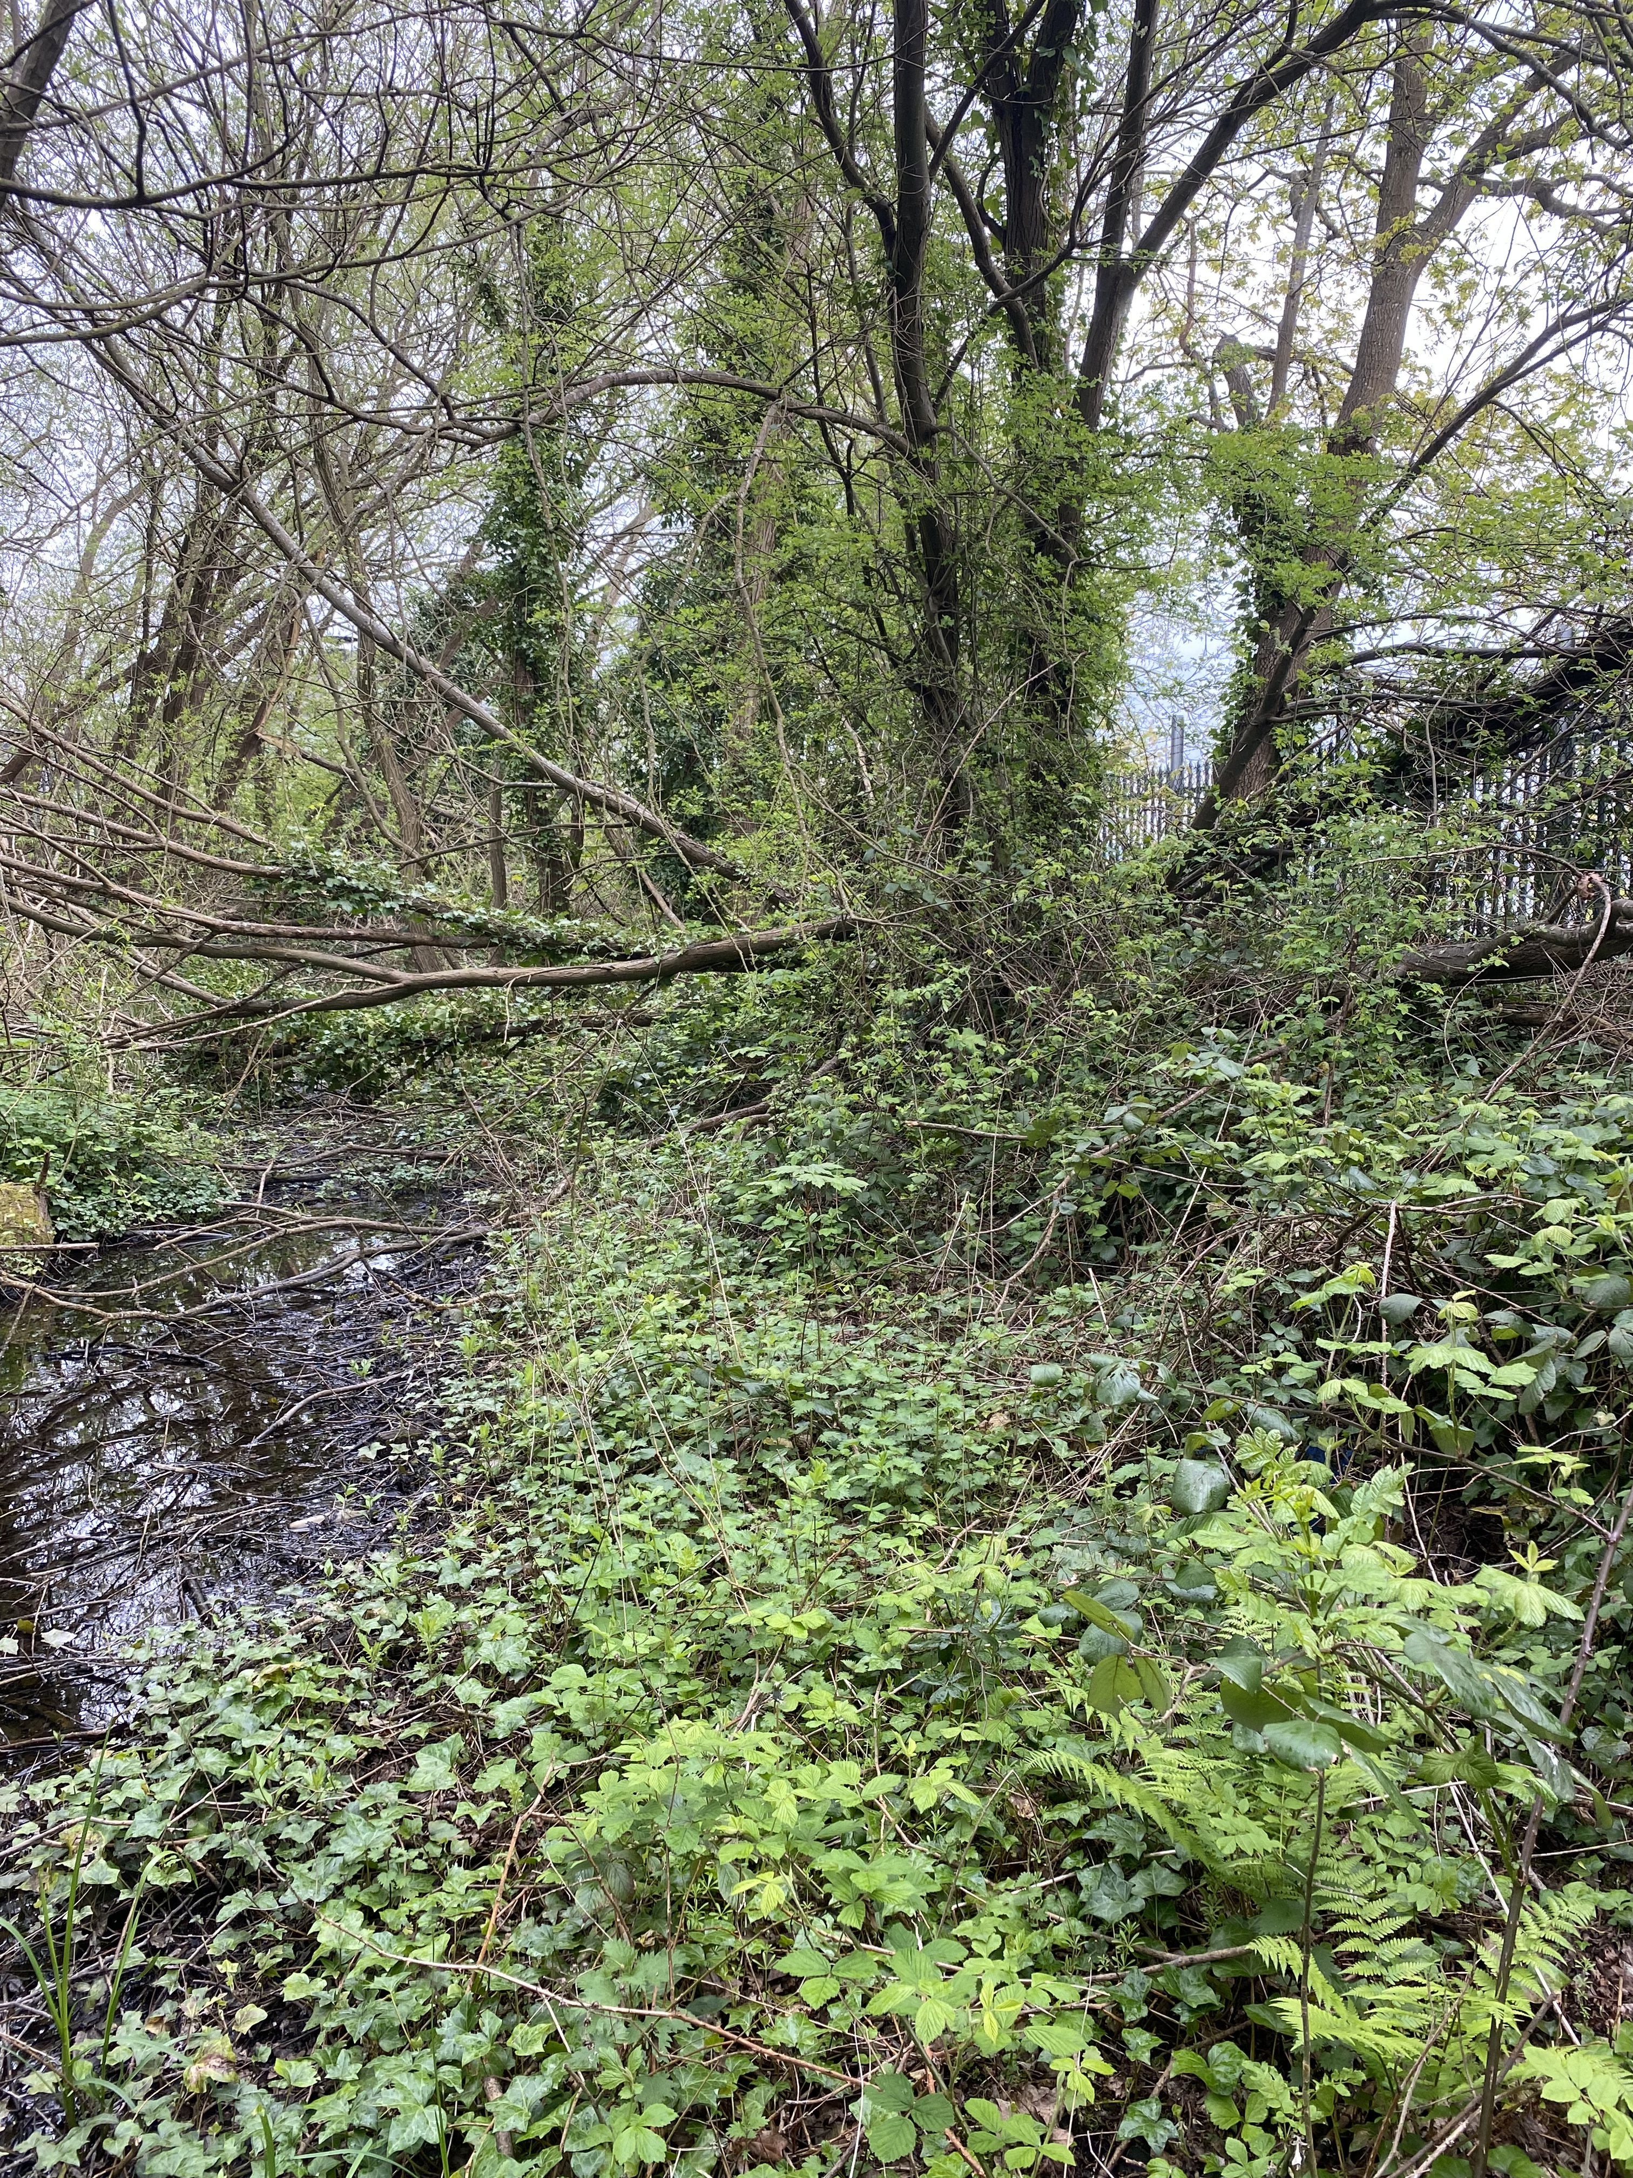

The main tasks are: (examples)

1/. Clear all the overgrown bushes, brambles and small self-seeded trees from the old tow path and channel.
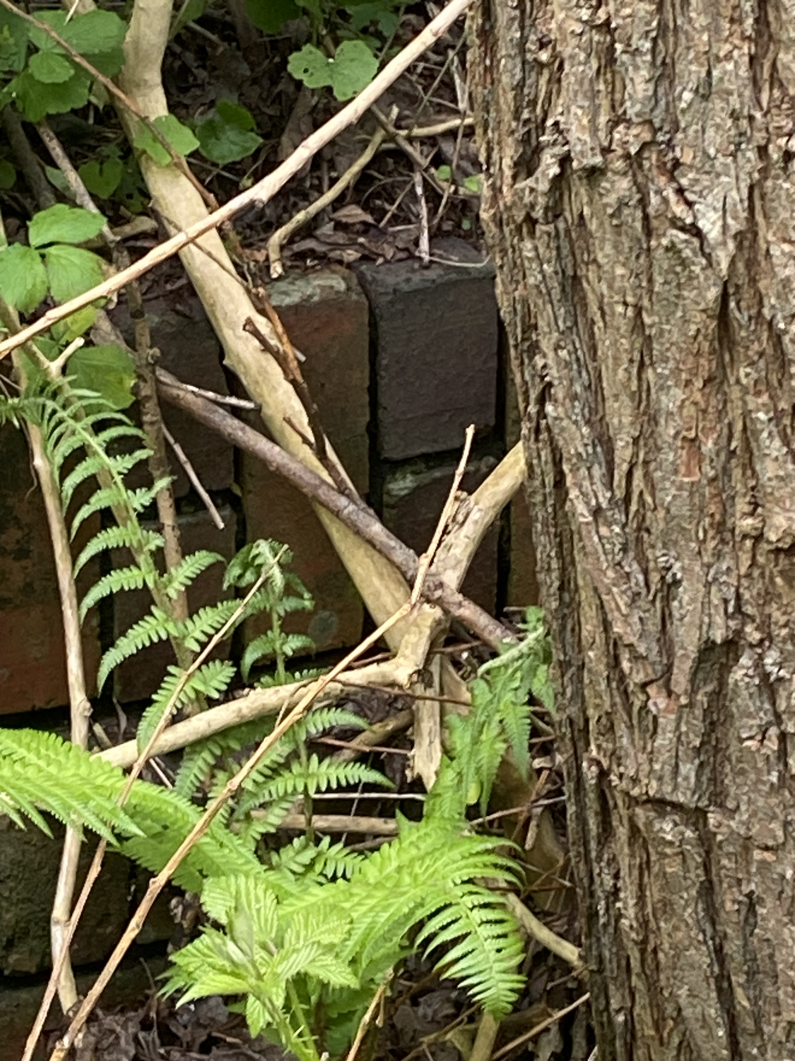
2/. Find and clear the edge of the towpath wall (so that it can be inspected / assessed for damage)

3/. Remove fly tipped rubbish.

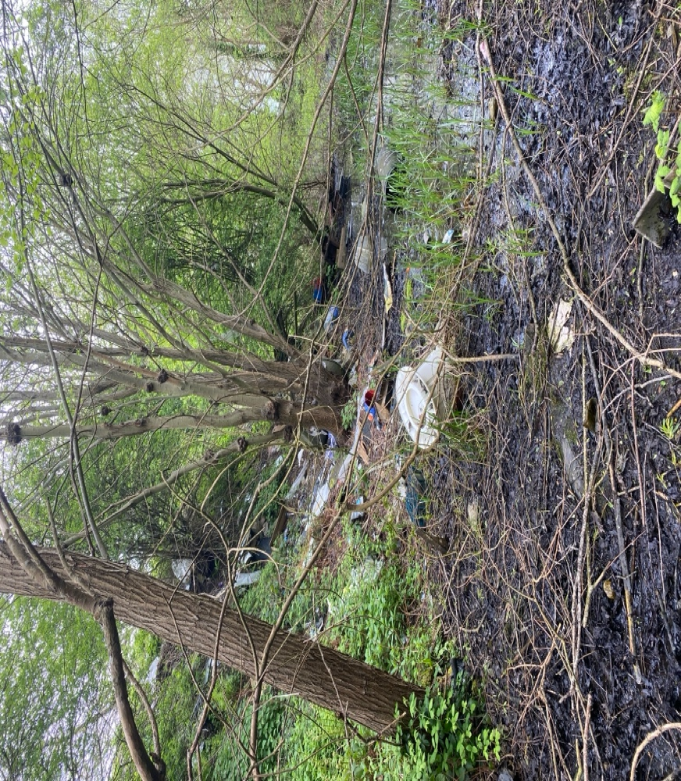

KEY SITE WIDE HAZARDS
- Examples:
- Falling off the edge of the tow path wall (approx 2ft – 3ft drop).
- Soft mud / water towards the centre of the channel.
- Leptospirosis from stagnant water.
WRG LOGISTICS
Site Leader(s)
Local Contact
CRT Contact (if nec)
Others
Site First Aiders
Number of Volunteers on site

HEALTH AND SAFETY
WRG is the “operational” subsidiary of The Inland Waterways Association, a registered charity.
- IWA provides the Health and Safety policy.
- WRG implements the Health & Safety policy through the WRG Board
All WRG tasks undertaken on the canal camp will be subject to CDM2015, and as such, all activities on site will be planned to identify hazards and minimise, or where possible eliminate, them during the design and activity planning stage.
All activities will be subject to a Safe System of Work / Method Statement / Job Description, with supporting risk assessments.
Canal Camp Leaders will implement the requirements and measures stated in the Task Plan with supporting risk assessments. The Canal Camp Leader will also be responsible for ensuring that volunteers work safely and in accordance with WRG policy and implement the following:
- All volunteers on the camp will be given a Health and Safety Induction / talk before being allowed to work on the site. The talk will reinforce general site procedures and provide specific details for the site and project they will be working on.
- The talk will introduce the documentation for the site and the projects being undertaken. Such documentation will include the Task Plan and accompanying Risk Assessment. Other documents such as IWA’s Incident Report Form will also be introduced during this brief.
- It will be made clear to volunteers that, as part of the Health and Safety at Work Act 1974, they have a legal responsibility in the Health and Safety operations of the project.
- All volunteers will be required to sign a register stating that that they have received the site induction talk and that they are willing to always follow the project leaders’ directions. The signed register will form part of the documentation pack to be taken onto the work site and will be returned to IWA Head Office on completion of the project to be kept on record.
- All relevant documentation (including a copy of the Practical restoration Handbook) will be taken on site every day.
- At all times during canal camps the site leader will ensure that volunteers are given sufficient instruction and supervision to enable them to undertake tasks requested of them in a safe manner. This will include frequent informal communication and utilisation of the Task Plan as a toolbox talk style briefing. Through regular communication the project leaders will check that volunteers understand the task in hand and help to ensure that Health and Safety is at the forefront of everyone's mind.
- In the event of an incident or near miss on site, leaders or another appropriate person will complete IWA’s Incident Report Form to inform IWA Head Office and the WRG Board. The WRG Board will seek to learn any lessons that result from the incident or near miss and, where necessary, mandate changes to the Operating Procedures.
CDM CONSIDERATIONS
CDM 2015 is the main set of regulations for managing health, safety and welfare on all small or large construction projects and applies to all construction work as well as maintenance. CDM regulations will apply to most, if not all Canal Camps.
Client: [Name of host restoration group]
Designer:
Contractor: Waterway Recovery Group
Are there any other contractors (or volunteer groups) on site?

Is your project ‘Notifiable’?
Please answer yes or no to the following question: Is your project expected to last MORE than 30 working days and have MORE than 20 workers working on site at any one time, OR involve MORE than 500 person days? Yes / No

- If you answered NO, then your project is not notifiable.
- If you answered YES, then your project is notifiable and will require the submission of a form F10 to HSE and further role appointments. Please contact WRG HO for more details ASAP.

ACCESS ARRANGEMENTS
[Details of access to the site, signage and any locked gates / keys required, etc]

[Details of parking arrangements]

WELFARE ARRANGEMENTS
[Details of arrangements for toilets, hand-washing facilities and other welfare]

EMERGENCY INFORMATION
[Nearest Hospital and other medical facility information]
approx xx miles from [the work site]

Directions located – Both WRG vans and in the accommodation by the First Aid Kit

Good mobile phone signal? Yes / No [service provider(s)]

ACCIDENTS AND INCIDENT REPORTING
All accidents, incidents or near misses should be reported via the report book located in the first aid box. These should be sent to IWA Head Office at the end of the camp. Serious accidents/incidents to be reported to the Duty Director and Head Office immediately.
Duty Director Phone No: ………..
Head Office Phone No: …………

BURIED OR OVERHEAD SERVICES
[Details of any utility services cables, pipes, etc, on or near the site]

GROUND CONDITIONS
[Details of ground conditions].

PERMISSIONS / INSPECTIONS
[Details of planning permissions, site owner permissions, wildlife permits, felling licences, waste licences, burn licences and other Environment Agency permissions].

ENVIRONMENTAL FACTORS
Example: Refuelling of chainsaws and brush cutters will be done on a spill mat in a specific location to be decided on site.
SITE MATERIALS
Fuel – Petrol |  | e.g. for chainsaws and brush cutters.
Fuel – Butane Gas |  | None on site.
Fuel – Diesel |  | None on site.
Other – Please add further rows |  | N/A
PLANT / EQUIPMENT ON SITE
Dumper
Roller
Excavator
etc – give full list, each on a new line
PPE (TO BE WORN AT ALL TIME ON SITE)  (Other task specific PPE will be detailed in the individual method statements) |  | COMPETENCY  Volunteers to be instructed in working methods and equipment as appropriate.  Only professionally trained chainsaw and brush cutter operators to be used.  SUPERVISION  Camp Leader: [Name]  Task Supervisors: [Name(s)]  SCHEDULING  [Details of what task is done when]
Safety helmet | Yes
Hi-viz vest | Yes
Safety footwear | Yes
Gloves | Yes
Safety Glasses | Yes
Life jackets, etc. – list in full with new line for each

SPECIFIC SITE WIDE RULES
Are there any specific site wide rules that volunteers need to be aware of?

- All WRG volunteers on site to have had the WRG induction procedure and assembled their PPE kits.
- Site leader to provide daily briefings to ensure all volunteers know the plan and their tasks.
- WRG volunteers must not enter any areas of the work site without permission.
- Care must be taken that WRG activities do not interfere with or affect the routine functioning of [site requirements of the landowner and neighbours, etc – details]
- When brush-cutters and chainsaws are in use, volunteers must keep a safe distance from the working area and follow any instructions given by the operator.

CHANGES TO THE PLAN DURING THE PROJECT (continue on a separate sheet as necessary)
Approved by |  | Signed
Retired by |  | Signed
Date | Nature of Review | Changes Required | Reviewer

