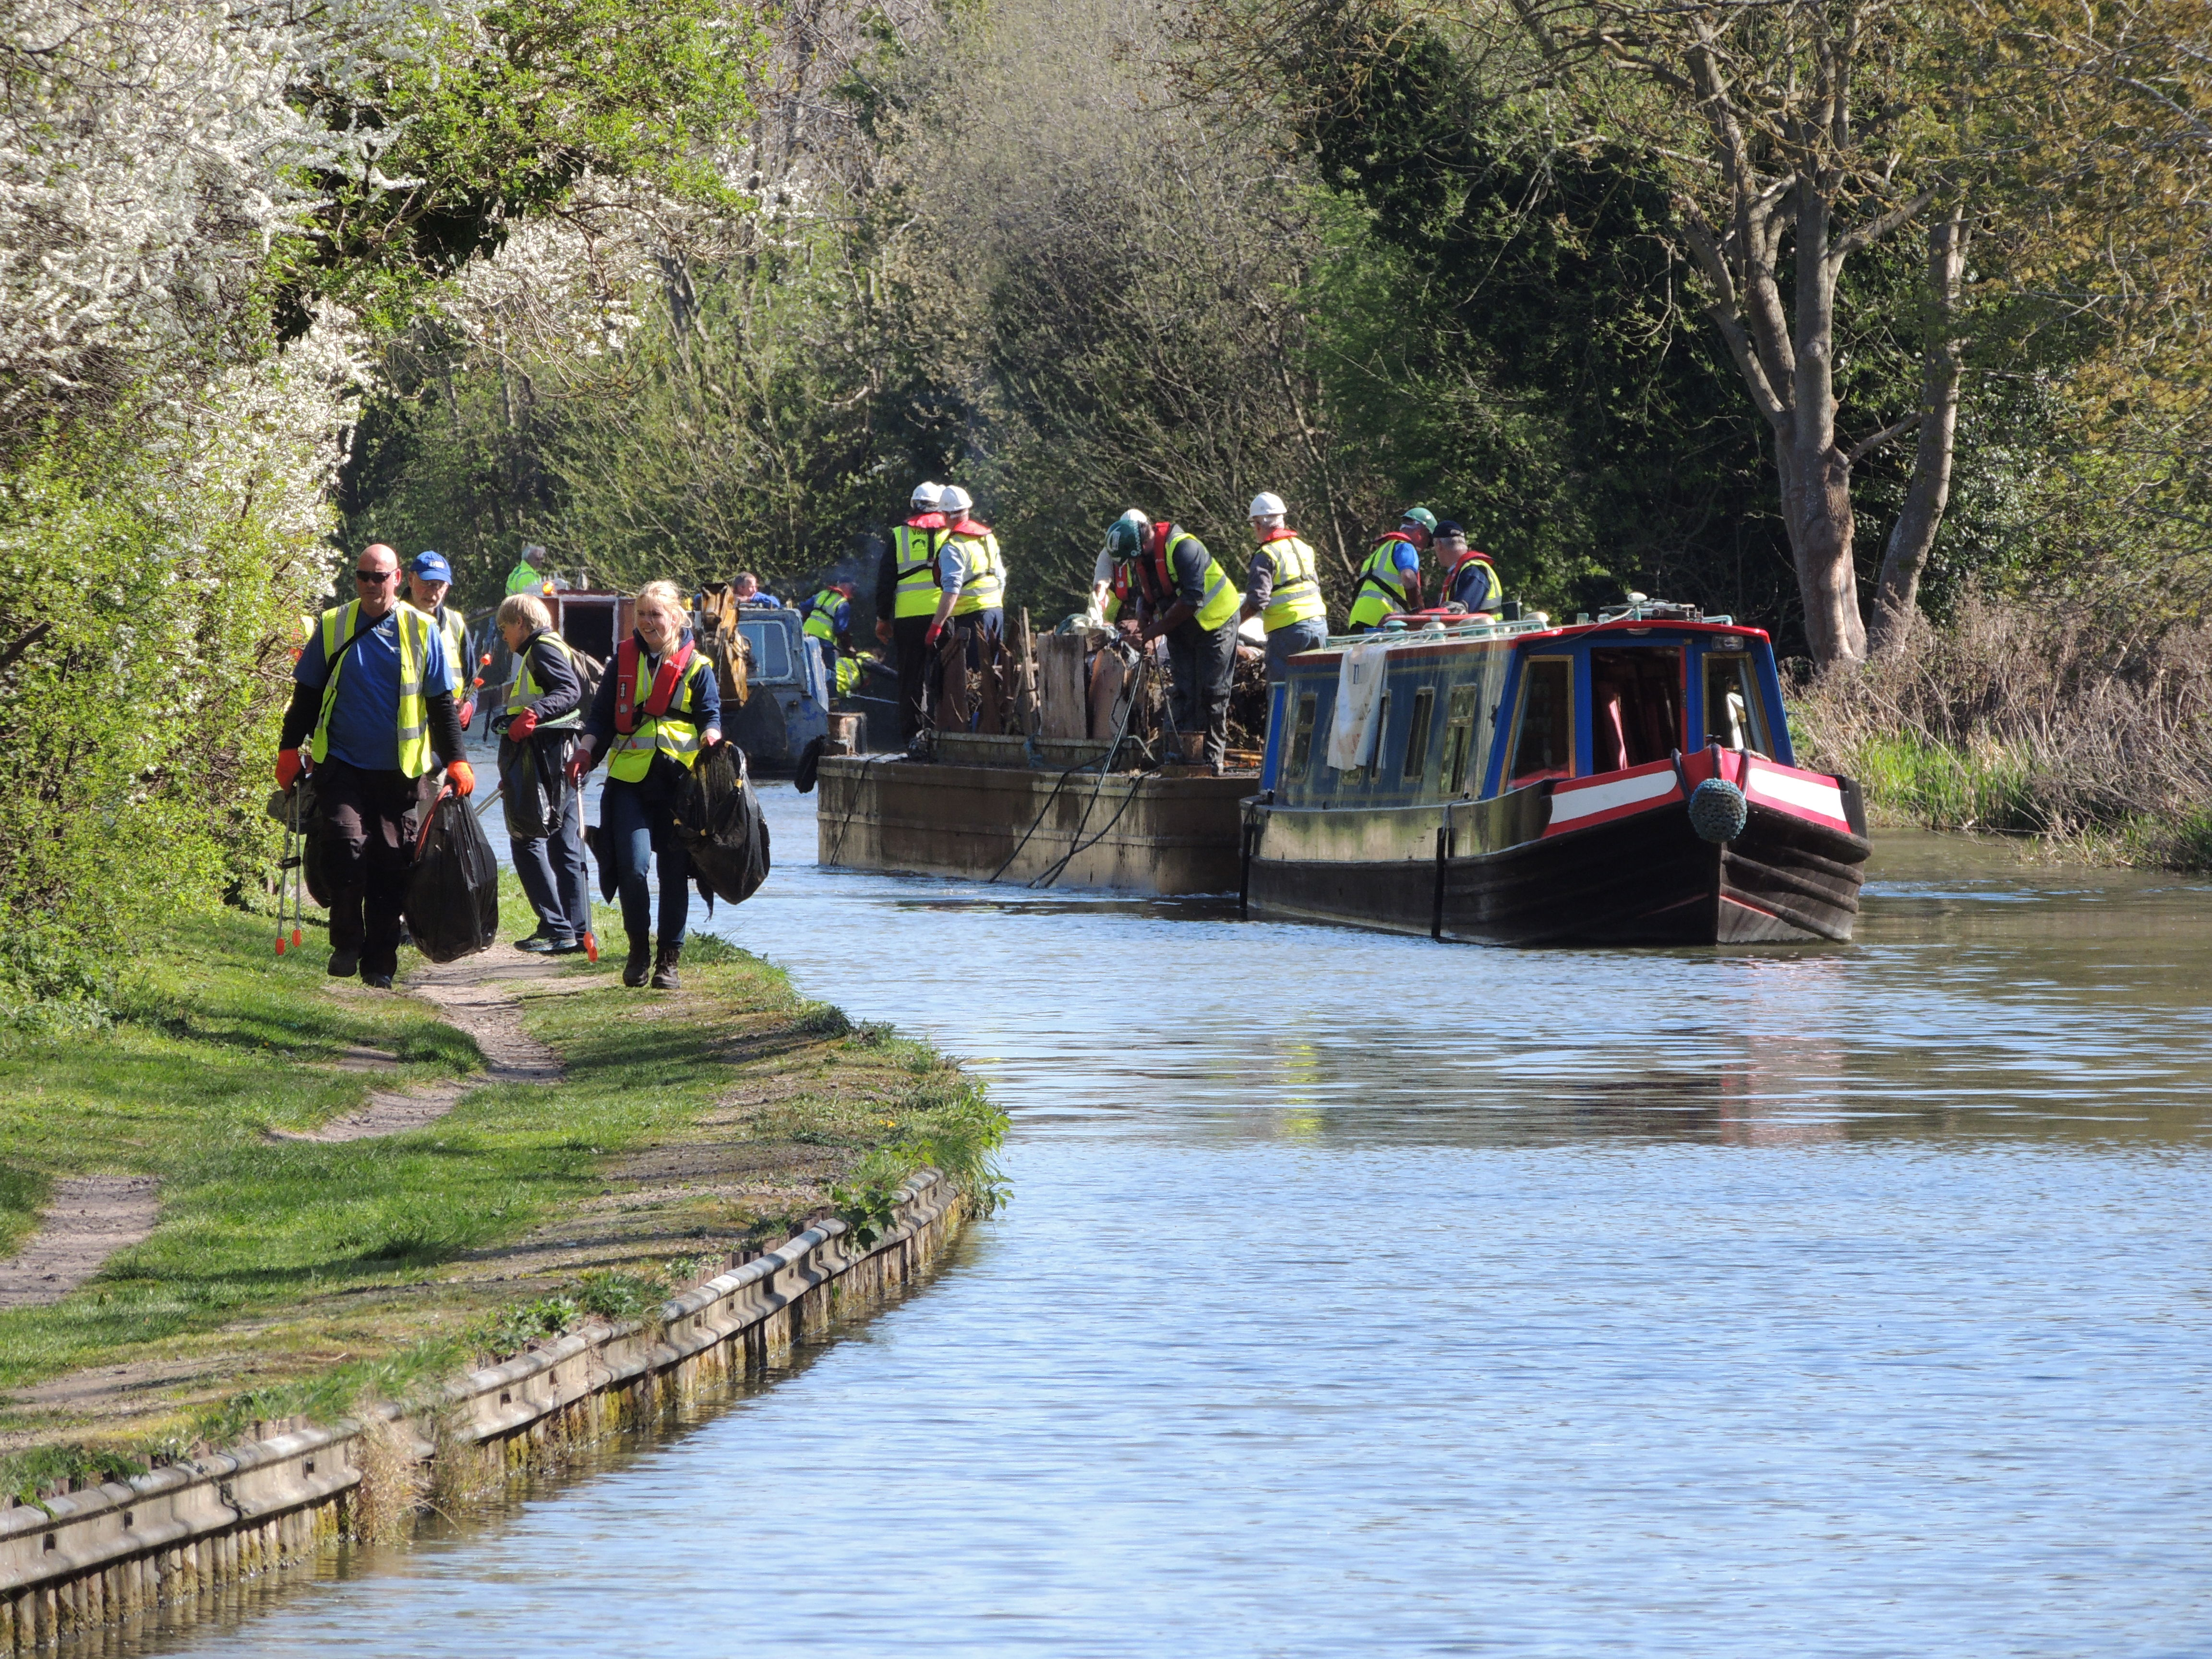

JOIN US


HELP US IMPROVE YOUR LOCAL WATERWAYS

#loveyourwaterways

LOCATION

DATE & TIME

Help us make a visible difference to your local waterway.

Tasks will include….

Equipment is provided and volunteers are asked to wear strong shoes, old clothes and to bring waterproofs. Tea and coffee is often available but a packed lunch should be bought if you intend to be out for the whole day.

[insert any additional info]
Contact Name:
Phone Number:
Email:
Website:

Contact Name:
Phone Number:
Email:
Website:

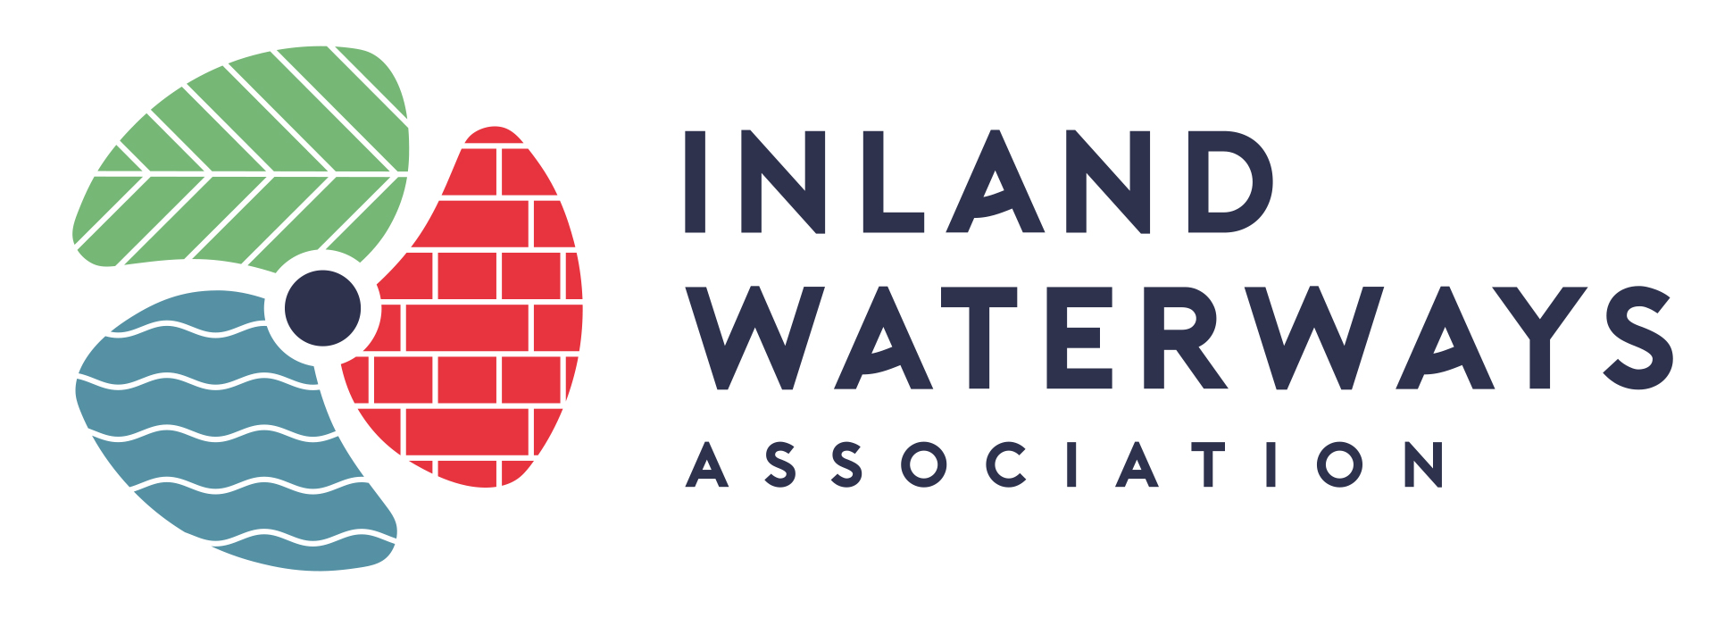

The Inland Waterways Association is a non-profit distributing company limited by guarantee. Registered in England no. 612245.
Registered as a charity no. 212342 Registered Office: Island House, Moor Road, Chesham. HP5 1WA. Tel: 01494 783453 Web: www.waterways.org.uk

