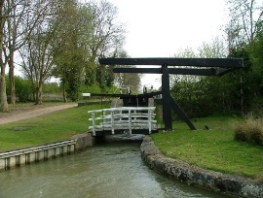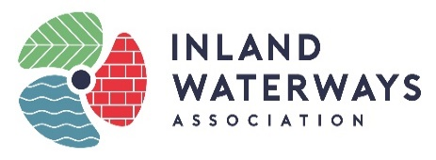­

**IWA NORTHAMPTON BRANCH**

**NATURE TRAIL CHALLENGE**

**Location: Northampton Arm of Grand Union Canal**

At each of the 17 locks on the Northampton Arm you will find two mosaic plaques set into the grass. One depicts an aspect of canal heritage, the other has a letter with an associated image from nature.

Use this form to collect all 17 letters and work out the phrase, then submit your form by email or post to earn yourself a Certificate of Achievement.

Enjoy your 4 ¾ mile walk.

Lock 1 _______ Lock 10 _______

Lock 2 _______ Lock 11 _______

Lock 3 _______ Lock 12 _______

Lock 4 _______ Lock 13 _______

Lock 5 _______ Lock 14 _______

Lock 6 _______ Lock 15 _______

Lock 7 _______ Lock 16 _______

Lock 8 _______ Lock 17 _______

Lock 9 _______

Phrase: ____________________________________________

Your name: …………………………………………………………………………………………………………………

Address (for certificate) or email (for electronic version): …………………………………………………………………………………………………………………………

……………………………………………………………………………………………………………………………………………………………………………………………………………………………………………………

Email your entry to [sandie.morton@waterways.org.uk](mailto:sandie.morton@waterways.org.uk)

Or post to 14 Baker Street, Gayton, Northampton, NN7 3EZ